Lab 2 Report: Intelligent Agents & the PEAS Framework
Course:Artificial Intelligence Lab
1.PEAS Specification(Smart Classroom Energy Agent)
PEAS Element
Performance measure
Description
Maintain occupant comfort, minimize energy consumption, ensure safe thermal operation.
Environment
Classroom interior, thermal condition/temperature, room occupants, external weather.
Actuator
Air conditioner operating modes (COOL, WARM, ECO, IDLE), fan speed control, alert notifications.
Sensor
Digital temperature sensor, occupancy motion/infrared sensor, timer/clock.
2. Environment Taxonomy (Classification)
Partially Observable: Sensor noise, calibration errors, or hidden external weather conditions prevent full state observation of occupant comfort.
Deterministic vs. Stochastic: The simulation code is deterministic based on rule mapping, but a real-world classroom environment is stochastic due to environmental unpredictability.
Dynamic: Temperature and occupancy states change continuously over time while the agent is deciding.
Discrete: Percept readings and action updates take place at distinct, scheduled time steps.
3.Percept and Action Trace Result

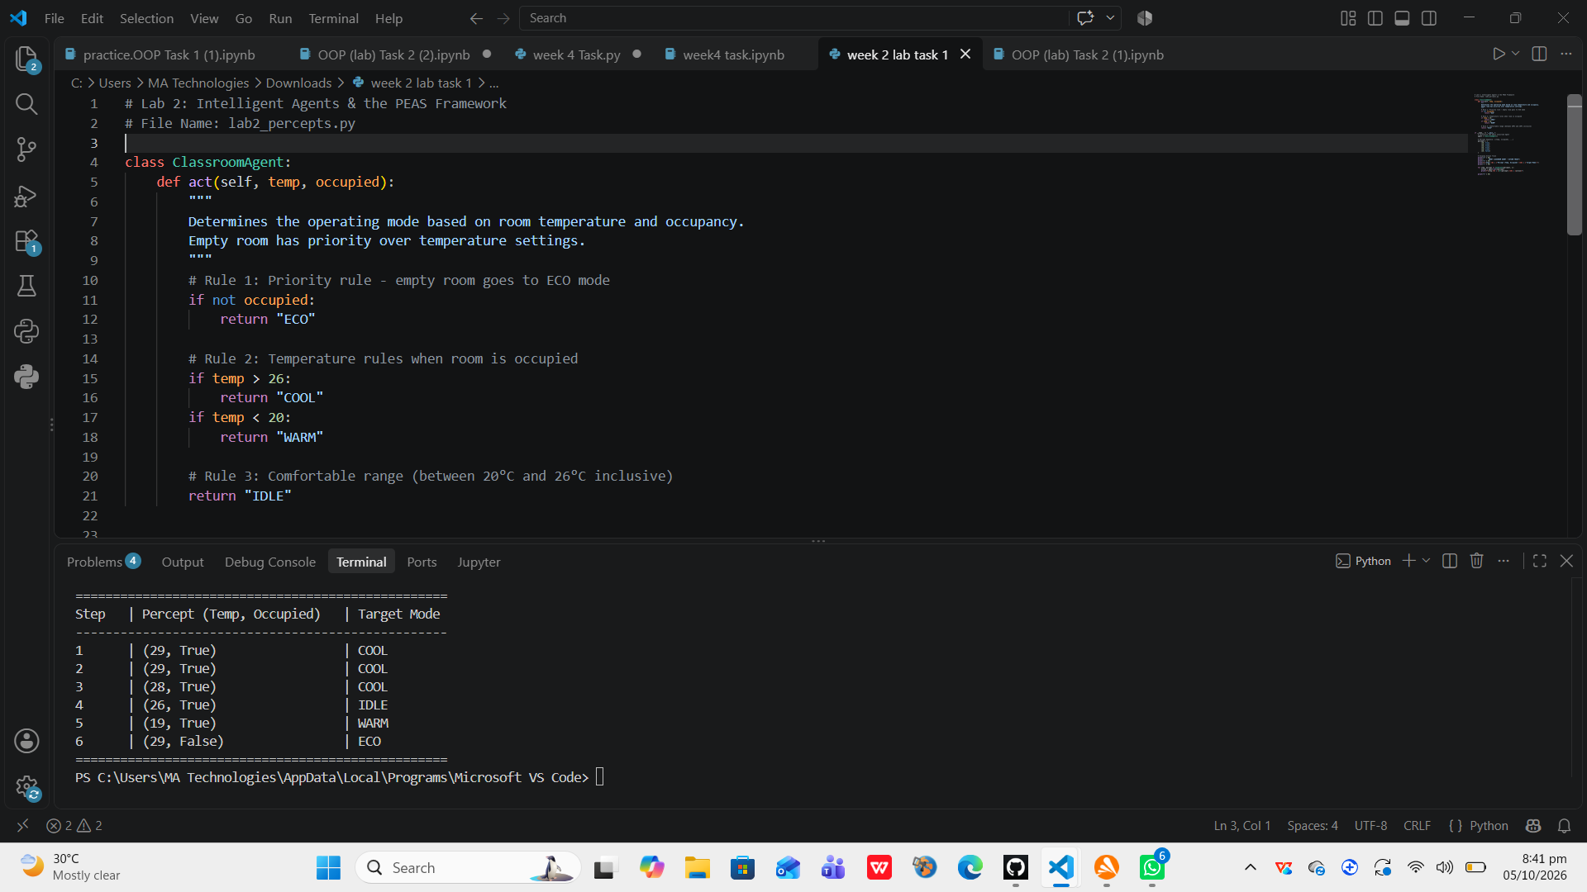

5. Reflection Questions
Q1: What did you learn today?
Answer:
I learned how to construct PEAS specifications for real-world systems, classify environments based on observability and determinism, and implement a basic reflex agent using Python conditionals.
Q2: How will you apply this in a real AI system?
Answer:
I will use the PEAS framework to formally define agent objectives, constraints, and sensor-actuator pipelines before designing autonomous system architectures.
Q3: What failed or surprised you?
Answer:
It was surprising to observe that a stateless reflex agent continuously issues redundant commands (like repeating COOL), demonstrating why state memory is essential for real-world controllers.
Q4: What would you do differently next time?
Answer:
Next time, I would implement a stateful agent that remembers its previous action to avoid redundant mode switching and incorporate hysteresis for stability.

